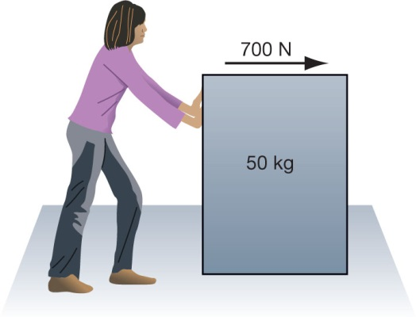

1. Anna puts a force of 400 N on a 20kg crate as shown.
2. The crate accelerates at 8 m/s2.

a Friction acts between the crate and the carpet. **Calculate** the size of the friction force acting on the crate.

Force = mass x acceleration

1. Fred puts a force of 500 N on a 10kg crate as shown.
2. The crate accelerates at 20 m/s2.

a Friction acts between the crate and the carpet. **Calculate** the size of the friction force acting on the crate.

Force = mass x acceleration

1. Anna puts a force of 400 N on a 20kg crate as shown.
2. The crate accelerates at 8 m/s2.

a Friction acts between the crate and the carpet. **Calculate** the size of the friction force acting on the crate.



f=m x a

F= 20 x 8

F = 160N

Friction = 400 – 160 = 240 N